Weobley NDP – HAVE YOUR SAY  even if you can’t come to the events | 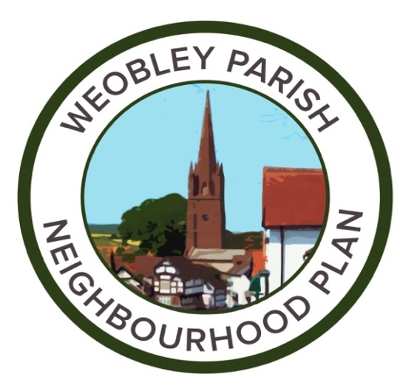

Name:
Postcode:
Gender:
Age group – choose one group: | Under 21; 22- 35; 36-50; 51-6 over 66

Please tell us what needs to be improved, when and where:
Business:
Community:
Countryside:
Education:
Health:
Housing :

Recreational Facilities :
Sport and Leisure :
Tourism:

Transport/Traffic/parking:
Young People:

Other comments:

Thank you very much for taking part!!

